081407001586

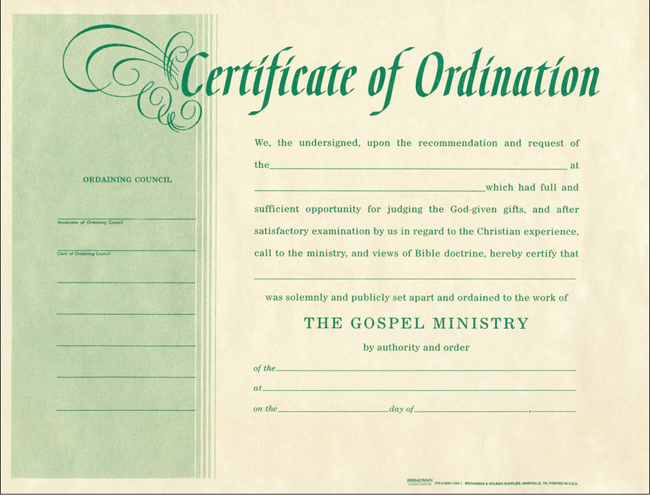

Certificate Directions

Ordaining Body or committee

Ordaining Body or committee

Name of Church

Name of person being Ordained

Date

Signatures of Ordaining Council/Body members

Name of Church

081407001593

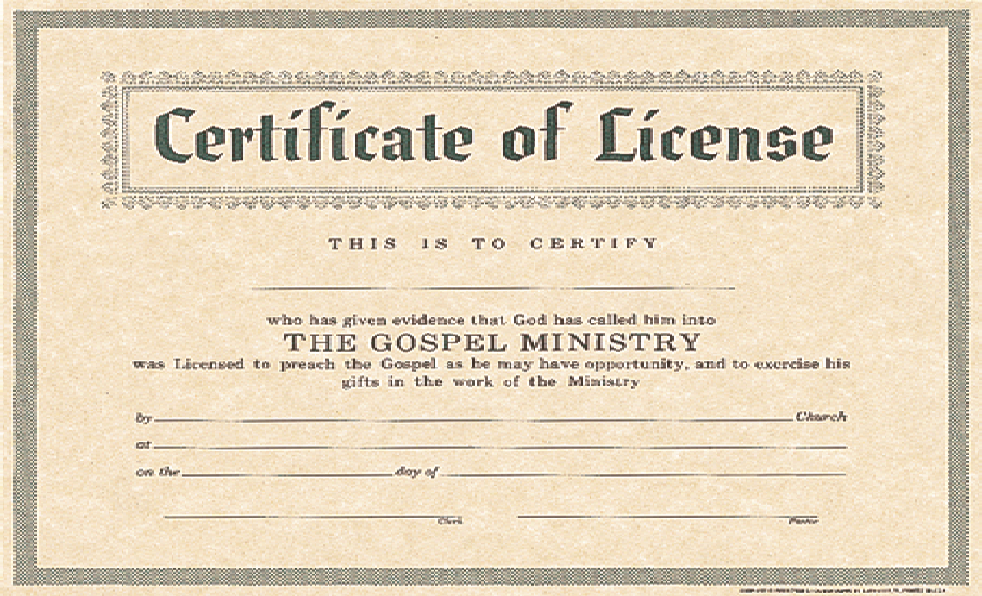

Church Clerk

Date

Church Address

Name of Church

Name of person to be Licensed

Church Pastor

081407001692

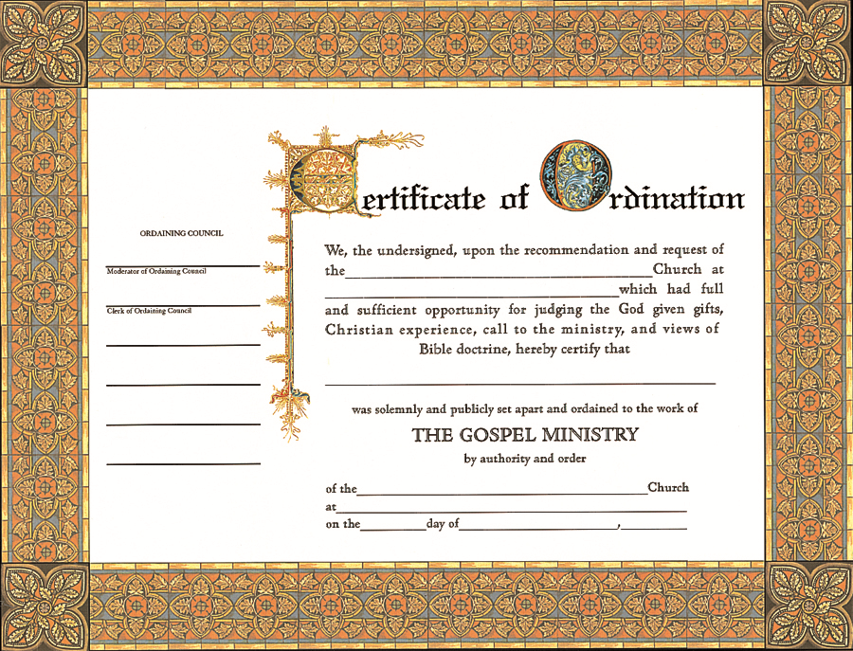

Date

Church Address

Church Name

Person to be Ordained

Church Address

Church Name

Signatures of Ordaining Council

Billfold Certificate 0801407001739

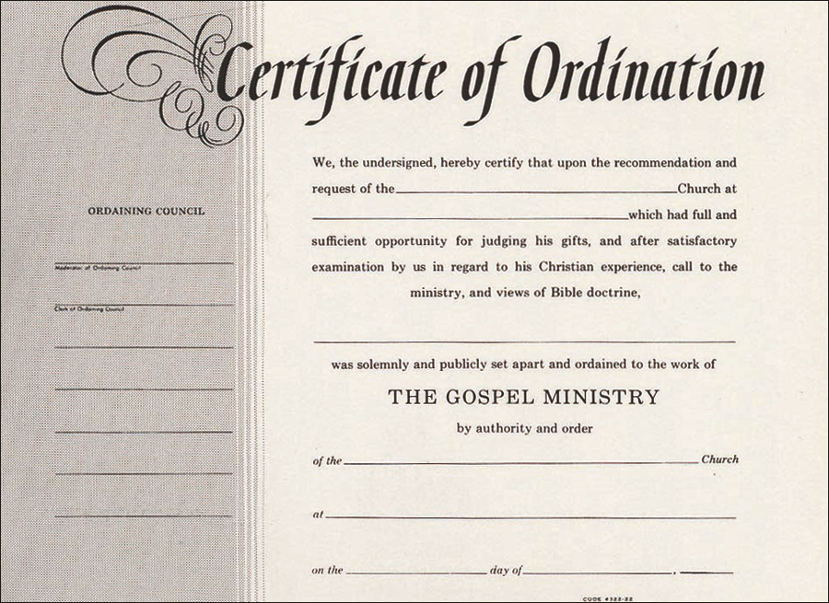

Billfold Certificate 0801407001387

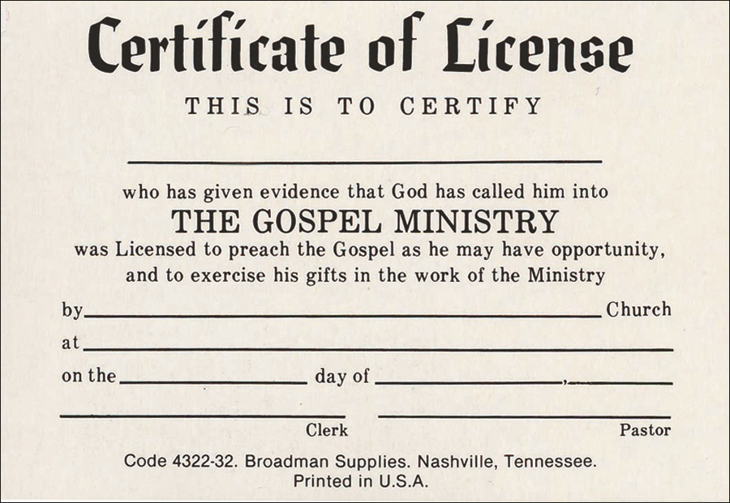

081407008820

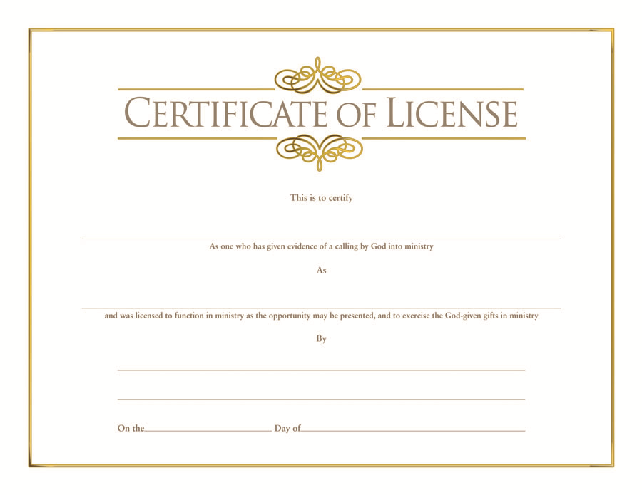

081407008851

