JOHN DOE | JOHN DOE
JANE DOE | John Doe
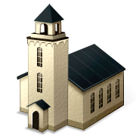  John  Doe | Jane Doe
John Doe | John  Doe

