John Doe | JOHN  DOE  First  Baptist Church
JOHN DOE | JOHN DOE  Study Leader
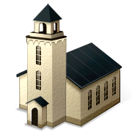  John  Doe   | John Doe  First  Baptist  Church
  John Doe | INCLUDEPICTURE "http://www.churchlogogallery.com/images/upload/OakLeafB.gif" \* MERGEFORMATINET  Jane Doe  Fall Bible Study Leader
Jane Doe  GREETER | John Doe

